**314 Reviewer PRELIM**

**Data**

* referred **to facts concerning objects and events** that could be **recorded and stored** on computer media.
* **raw** but **not complete.**

**Information**

* when **data was processed**.
* it is **detailed.**

**Metadata**

* is *data about data* through which the **end-user data are integrated and managed.**

**Database**

* is an **organized collection of logically related data**.
* **store data** or **storage**.

**DBMS –** is a **software that allows creation, definition, and manipulation of database**, allowing **users to store, process and analyze data** easily.

* also **provides protection and security** to the databases.

**CHARACTERISTICS OF DBMS**

* **Data stored into *Tables <- columns and rows***
* **Reduced Redundancy *-> limit iteration***
* **Data Consistency *-> doesn’t change***
* **Support multiple user and Concurrent Access**
* **Query Language**
* **Security**

**COMPONENTS OF DBMS**

* **Hardware**
* **Software**
* **Data**
* **Procedures**
* **Database Access Language**

**DATABASE ARCHITECTURE**

* **1-tier DBMS –** when the **database is directly available to the user** for using it **to store data**.
* **2-tier DBMS** – includes an **application layer between the user and the DBMS**, which is **responsible to communicate the user’s request** to the **database management system** and then **send response from the DBMS to the user.**
* **3-tier DBMS –** is the **most used architecture for web applications**.

**DATABASE MODEL**

* Defines the **logical design and structure of a database**.
* Defines how data will be **stored, accessed, and updated** in a database management system.

**RELATIONAL MODEL**

* Is the **most widely used database model**.

**History of Relational Model**

* It is introduced by **Ted Codd** in **1970.**
* Uses concept of **mathematical relation.**
* First ***commercial implementations of the relational model:***
* **Oracle DBMS**
* **SQL/DS System (IBM)**

***More databases…***

* **PhpMyAdmin**
* **MySQL Workbench**
* **MongoDB**
* **Firebase**
* Popular **RDBMSs:**
* **SQL Server & Access (Microsoft)**
* **DB2 & Infomix (IBM)**
* Standard for ***commercial RDBMS:***
* **SQL query language**

***Terms and Meaning:***

* **IBM – *International Business Machines***
* **DBMS – *Database Management System***
* **RDBMS – *Relational Database Management System***
* **SQL – *Structured Query Language***

**Terminologies**

* Relational Model represents data as a **collection of tables.**
* A ***table*** is also called a **relation.**
* 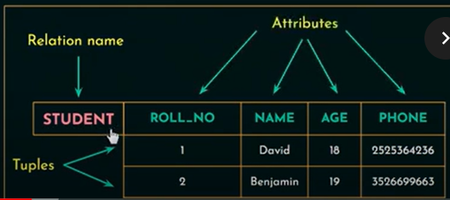Each ***row*** is a **tuple.**
* ***Column headers*** are **attributes.**
* **Domain:**
* A **set of atomic values allowed** for an attribute.

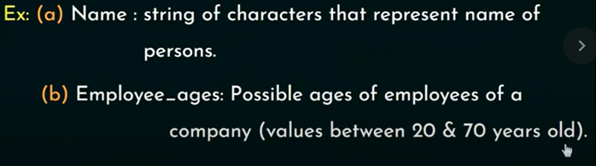

* **Relation Schema:**
* Describes a **relation.**
* Made up of a **relation name *R*** and a **list of attributes ,,.**
* **Degree (**or **Arity)** of a **relation:**
* **Number of attributes** in a ***relation schema.***

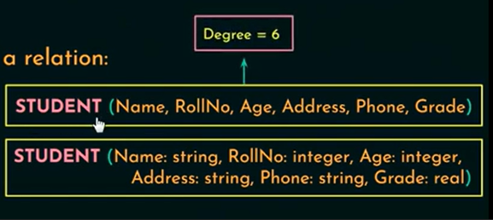

* **Cardinality:**
* **Total number of tuples** present in a ***relation.***

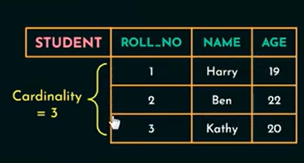

* **Relational state (**or **relation instance):**
* **Set of tuples** at a given time.

**Terminologies**

* **Entity**
* A “***thing***” in the **real world** with an **independent existence.**
* May be an **object** with **physical existence** (ex. ***House, person***) or with a **conceptual existence** (ex. ***course, job***).
* 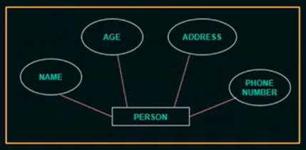**Attributes:**
* Properties that **describe the entities.**

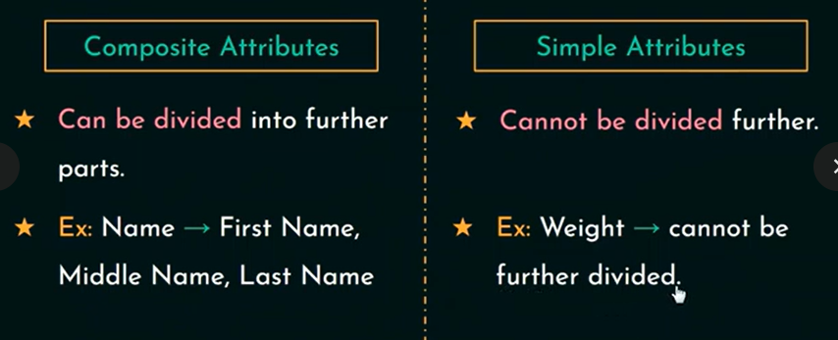

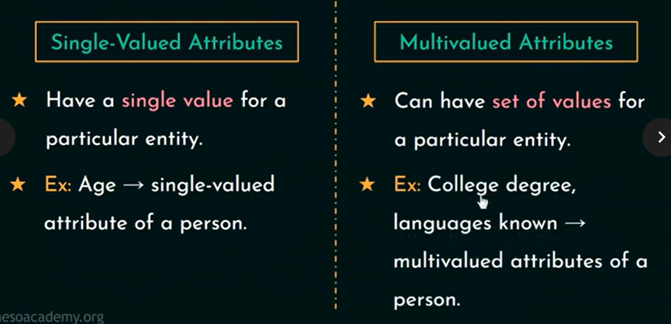

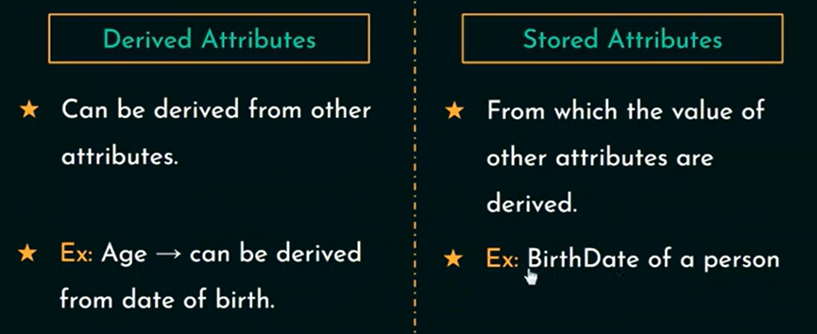

* **Complex Attributes:**
* Has **multivalued & composite components** in it.
* **Multivalued attributes –** represented within ‘***{ }***’.
* **Composite attributes –** represented within ‘***( )***’.
* Ex. **{CollegeDegrees(College, Year, Degree, Field)}**
* **Null Values:**
* **Null** is something which is **not applicable** or **unknown.**

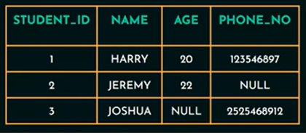

* 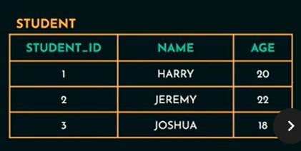**Entity Type:**
* A ***collection of entities*** that have the **same attributes.**
* Ex. **STUDENT**
* **Entity Set:**
* 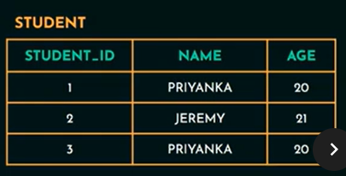That attribute that is capable of **identifying each entity uniquely.**
* Ex. **Roll number of a student**
* **Value Set of Attributes:**
* The ***set of values*** that can be **assigned to an attribute.**

**ENTITY RELATIONAL MODEL (ERD)**

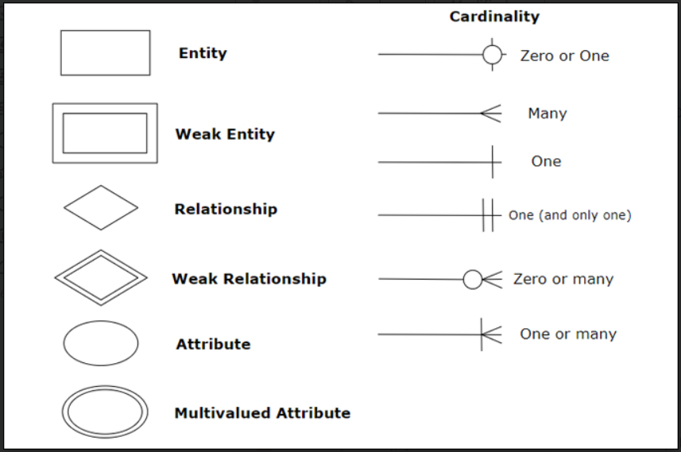

**ENTITY-RELATIONSHIP (ER) DIAGRAMS**

* 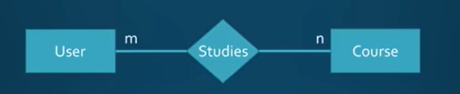**Depicts entities,** the **relationships between them and attributes** of those ***entities and relationships***.

**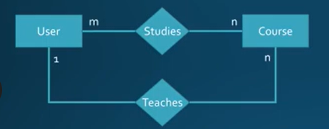*Types of CARDINALITY:***

* **One-to-one**
* **One-to-many**
* **Many-to-many**

**Cardinality Rules of Thumb:**

* Can a **user** study multiple courses, or only one?
* **Multiple: ‘n’ next to course**
* **Only one: ‘1’ next to course**
* Can a **course** be studied by multiple users, or only one?
* **Multiple: ‘m’ next to user**
* **Only one: ‘1’ next to user**

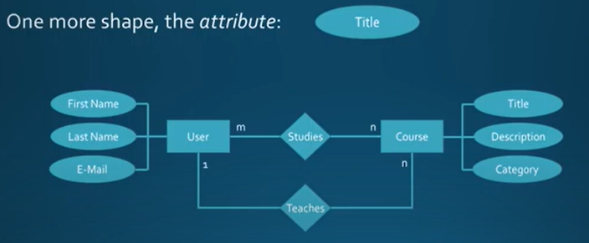

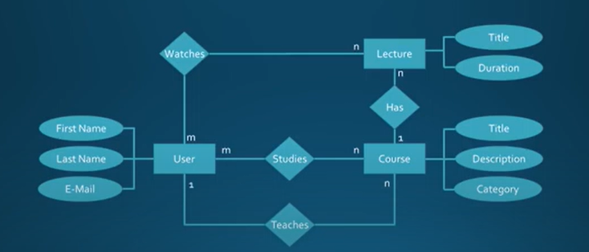

***What is PRIMARY KEY?***

* The **primary key (PK)** is a **column** or **set of columns** that **uniquely identifies** each row in the table.
* A ***table*** can have only **one Primary Key,** which can be made up of **one** or **more fields.**
* The *primary key* must contain **unique values,** should **not be null** and should **never change.**

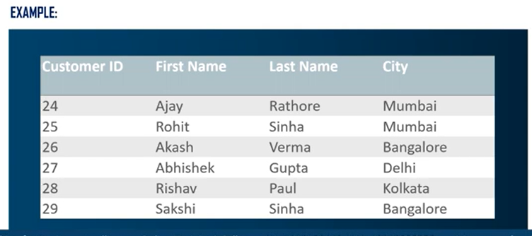

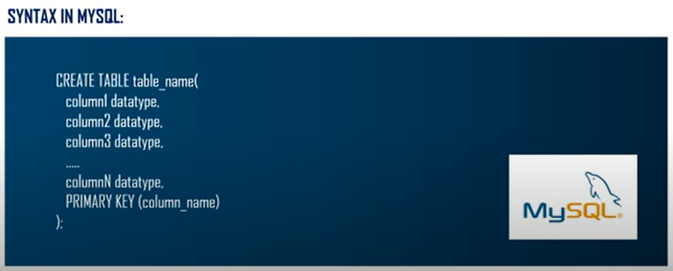

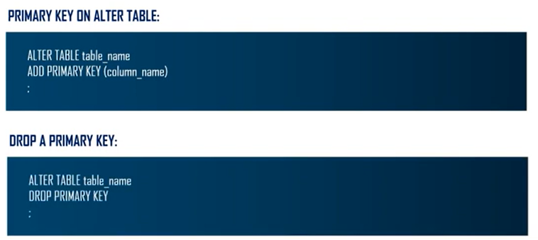

***What is FOREIGN KEY?***

* The **foreign key** is a **column** or **set of columns** that is used to **links two tables together**.
* The foreign key of one table **helps to connect** with the **primary key of another table.**
* **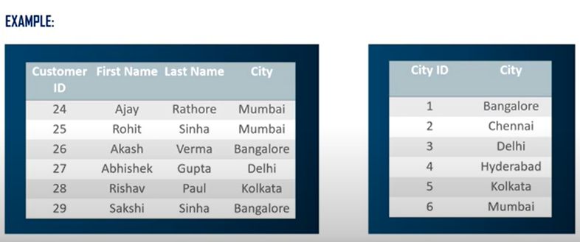***Foreign key*is used to **create links between tables.**

